Steven Mathias
7/19/2026
CS 499 Capstone
Module Three
Enhancement One: Narrative
For enhancement one, I chose to adapt artifact one, the weight loss tracking android studio application developed in CS 360 – Mobile Architect and Programming. The application is designed to allow a user to login or register if no previous account was created. Once authenticated, a homepage is presented that shows the current weight (if entered) as well as an option for adding a new entry, viewing current progress represented in the progress bar, and setting a new goal. Additionally, a calendar button is provided to access the calendar grid showing all previous weight entries and the date that they were entered.
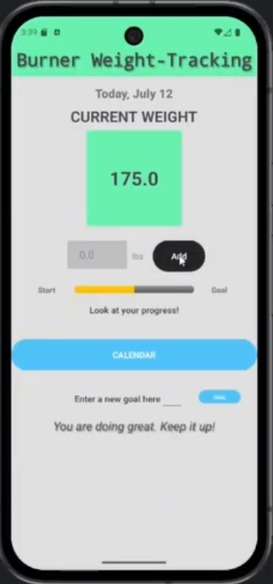
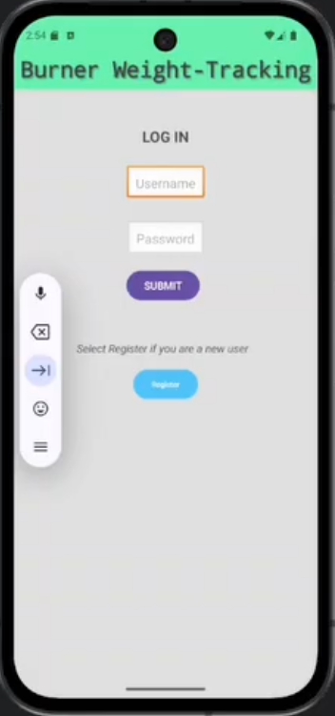

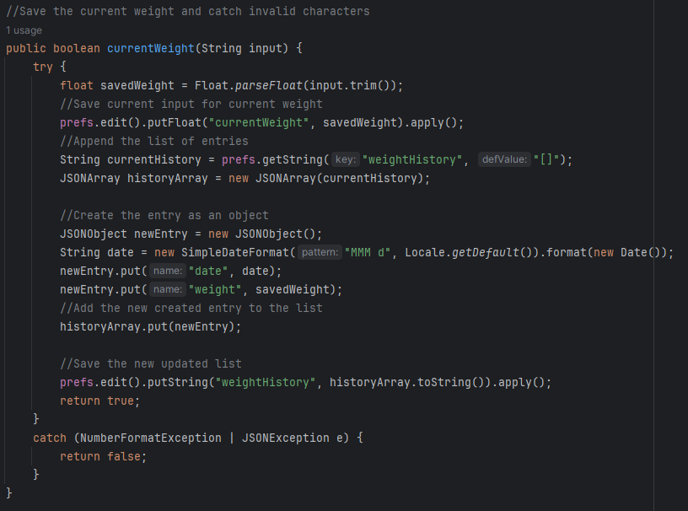
This artifact demonstrates the ability to code in Java, as well as create a functional user interface. The greater demonstration of skills is the ability to join these two components to form a seamless flow for a user to interact with. Furthermore, category one is titled “Software Engineering and Design” which presented a great opportunity to enhance this application’s architecture. In its original state, the application had a login and homepage class that were handling all the user interface mechanics including buttons and display, in addition to all the math calculations and logic. Creating two new controller classes to take over the calculations demonstrates an ability to not only enhance an application but think differently about how a program functions. In addition, I demonstrated the ability to create a cohesive project that handles various elements, methods and classes that all work together. Many of the components interact with other pages, such as the calendar page needing to take the stored weight in the JSON list to accurately reflect what the user has entered. I do believe that these criteria resolve the course outcomes that relate to this artifact and enhancement.
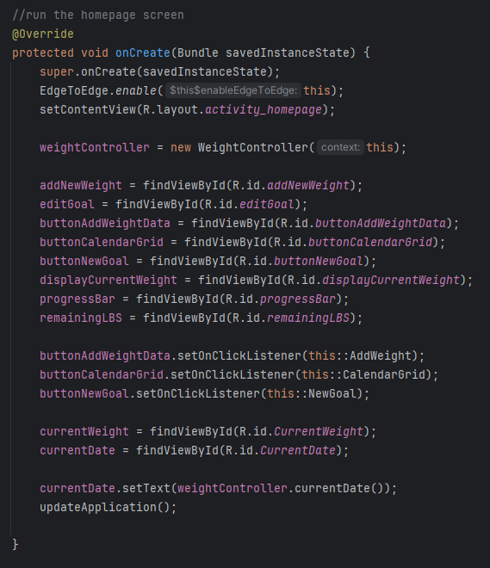
The biggest challenge was linking all the java files and correcting the communication once the enhancements were made. By creating these additional classes to handle the calculations and fixing the error in the current weight calculation, this created a mostly different architecture that needed re-working to allow them to communicate with each other. I learned that sometimes there may be a method that works best for one area, but not for another. Therefore, it is important to understand how to strike a balance that works best for the overall program or application.

